Name Date Class
LESSON 2
Key Concept Builder
Changing Populations
Key Concept How do populations change?
Directions: Answer each question in the space provided.

How Populations Change
Question | Answer
1. How does a population of spiders
change when a large group of
eggs hatches all at once?
2. What will most likely happen to
many of the young spiders?
3. How will this change the
population?
4. What are a population’s birthrate
and death rate?
5. How does the relationship
between birthrate and death
rate affect population size?
Directions: Use the graph to answer each question.
6. What type of growth is shown in
the graph?
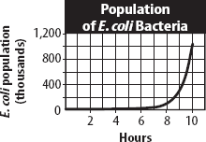
7. When does a population grow in this
pattern?

8. Why can’t this type of growth continue forever?

34 Populations and Communities

