Name Date Class
LESSON 3
Key Concept Builder

Refraction and Lenses
Key Concept What happens to light as it moves from one transparent substance to another?
Directions: Use the diagram to answer each question or respond to each statement on the lines provided. The
arrows represent light rays moving through a medium.

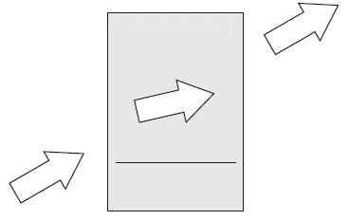
medium = water
C.
medium = air

medium = air
B.

A.
Normal to the
boundary

1. What is meant by refraction of light?

2. Name the two places in the diagram where refraction occurs.

3. Explain what is meant by the index of refraction.

4. What happens to the speed of the light when it travels between transparent substances
such as air and water? Why?

5. Why does the arrow labeled B show a different direction from the arrows labeled A and C?

6. Explain why the light in the diagram (arrow C) refracts away from the normal.

Light 53

