Name:___________________
RESEARCH PROJECT

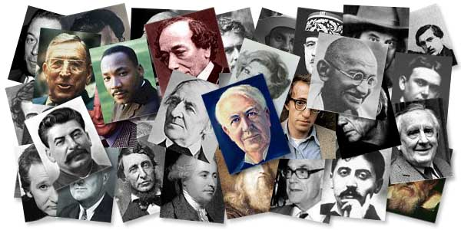
STEP 1: RESEARCH & WRITE REPORT
Person Chosen:______________ Notes Page Due:___________ Final Report Due:___________
Working alone choose an important historical figure from the list provided. You will do research on your subject and write a report that answers the questions on the Research Notes Page. This part of the project has many steps: choosing a person, researching, taking notes, writing a rough draft, proofreading and writing a final draft.

STEP 2: PRESENTATION!
Presentations will be on Friday, May 15th.
Now, you will be dressing up as the person you studied! On the day of the presentation, you will be in character as your subject and must be prepared to answer questions as if you really are that person! You do not need to buy a special costume. Please borrow or make a costume from items you have at home. You will need to present your information, either in our zoom meetings (of if we are back in school in the front of the class).
Research Notes
What is the full name of the person you studied?
___________________________________________________________________
When and where were they born?
___________________________________________________________________
What was their childhood like?
_______________________________________________________________________________________________________________________________________________________________________________________________________________________________________________________________________________________________________________________________________________
What are the important events and accomplishments of their adult years?
______________________________________________________________________________________________________________________________________________________________________________________________________________________________________________________________________________________________________________________________________________________________________________________________________________________________________________________________________________________________________________________________________________________________________________________________________________________________________________________________________________________________
Is he/she still alive? If not, how did they die? IF alive, what are they doing now?
______________________________________________________________________________________________________________________________________
If this person gave you one piece of advice, what do you think it would be?
_________________________________________________________________________________________________________________________________________________________________________________________________________
Additional information that is important about your subject:
_____________________________________________________________________________________________________________________________________________________________________________________________________________________________________________________________________________________________________________________________________________________________________________________________________________________________________________________________________________________________________________________________________________________________________________________________________________________________________________________________________________________________________________________________________________________________________________________________________________________________________________________________________________________________________________________________________________________________________________________________________________________________________________
Essay Outline
1st Paragraph: Early Life
- Introduce famous person.
- Where were they born?
- Where did they live?
- Provide information about the parents.
2nd Paragraph: Childhood
- Where did they live as a child?
- What type of childhood did they have?
- What school(s) did they attend?
3rd Paragraph: Adulthood
- Did they attend college? Further education?
- First Job?
- Did they marry? If so, who?
- Did they have children? If so, who?
- Where did they live?
4th Paragraph: Becoming Famous
- What are they famous for? (Politics, music, film, etc)
- How did they first become interested in this area?
- What are some important accomplishments? What qualities did they have to help them achieve these important accomplishments?
- Have they received any awards or achievements?
- Any other details: exciting/difficult times, important events, interesting places they have traveled, etc
5th Paragraph: Life Today – Or- Later Life (If person is no longer living)
- Where is this person living now or where were they living at the end of their lives?
- How old are they or how old were they when they died?
- If still ALIVE:
- What is their life now?
- Are they still active in the area they are famous?
- Have they had important events recently or coming up?
- If NO LONGER LIVING:
- When and where did they die?
- Where are they buried?
- How are they remembered today?
- If this person could give you some advice, what would it be?
Name:________________________ Person Chosen:_______________________
GRADING RUBRIC
REPORT: CONTENT
____/5 Name of the person studied
____/5 When and where were they born?
____/10 What was their childhood like?
____/10 Important events and accomplishments of their adult years
____/10 What qualities did this person have that helped them achieve success?
____/5 Is the person living or dead?
____/5 If this person could give you one piece of advice, what would it be?
____/10 Report contains at least 5 paragraphs
REPORT: GRAMMAR/MECHANICS
____/25 Overall, student uses correct spelling, grammar, and punctuation.
REPORT; PRESENTATION
____/5 Student maintains eye contact with audience.
____/5 Student’s voice I audible throughout presentation.
____/5 Student appears confident throughout presentation.
REPORT TOTAL:__________/100 =

VISUAL DISPLAY:
_____/2 Name of person in large writing
_____/5 Five basic facts: Birth/death, where they lived, family, etc.
_____/5 A five sentence paragraph about why they are famous
_____/3 3-5 Pictures (either printed or hand drawn)
_____/5 Must be nicely designed and no spelling/punctuation/capitalization errors
Visual Total: ______________/20 =

Examples:

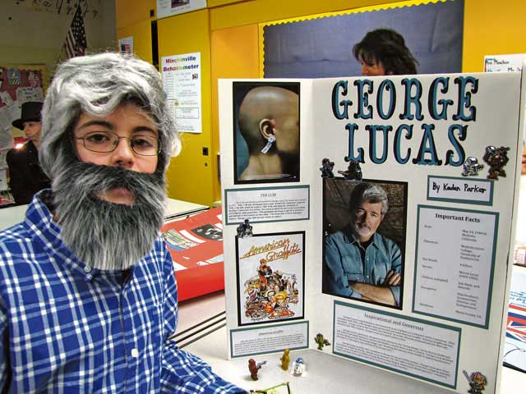
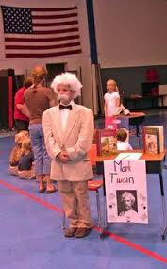

List
(Circle your top 3)
Influential Americans/Historical Figures
- Abraham Lincoln
- George Washington
- Franklin Delano Roosevelt
- Alexander Hamilton
- John Marshall
- Martin Luther King Jr.
- Thomas Edison
- Woodrow Wilson
- John D. Rockefeller
- Ulysses S. Grant
- Henry Ford
- Theodore Roosevelt
- Mark Twain
- Andrew Jackson
- Andrew Carnegie
- Wright Brothers
- Thurgood Marshall
- Booker T. Washington
- William Randolph Hearst
- John F. Kennedy
Humanitarians/Educators
- Rachel Carson
- Frederick Law Olmsted
- Horace Mann
- Samuel Gompers
- Jane Addams
- Rosa Parks
- Helen Keller
- Eleanor Roosevelt

Scientists/Inventors
- James D. Watson
- Enrico Fermi
- Sir Francis Bacon
- Louis Pasteur
- Sir Isaac Newton
- Eli Whitney
- Thomas Edison
- Henry Ford
- Edwin Hubble
- Jonas Salk
- Marie Curie
Sports
- Jesse Owens
- Pele
- Carl Lewis
- Hank Aaron
- Willie Mays
- Joe DiMaggio
- Jackie Robinson
Religion
- Jonathan Edwards
- Lyman Beecher
- Saint Augustine
- Billy Graham
World Leaders
- Nelson Mandela
- Gandhi
- Mother Teresa
- Alexander the Great
- Charlemagne
- Napoleon Bonaparte
- Winston Churchill

Character Development Worksheet 1 - Researching Your Character
Name of Character/Person:
_______________________________________________________________
Date and place of birth: ______________________________________________________________________
Date of Death: _____________________________________________________________________________

Early Life
Parents and their occupations:
______________________________________________________________________________
______________________________________________________________________________
Siblings and ages: ______________________________________________________________________________
______________________________________________________________________________
Significant events in early life: ______________________________________________________________________________
______________________________________________________________________________
Education
How and where were you educated? ______________________________________________________________________________
______________________________________________________________________________
______________________________________________________________________________
Current Life
Where do you live and what kind of home do you have? How long have you lived there? _______________________________________________________________________________________________________________________________________________________________________________________________________
Are you married? Where, when, and what is your spouse’s name and occupation?
_____________________________________________________________________________________________________________________________________________________________________________________________________________

