Name Date Class
Interpreting Data LESSON 2: 20 minutes
Skill Practice

How do populations change in size?
Birthrate and death rate change the size of a population. In the 1700s, the death rate of sea
otters in central California was extremely high because many people hunted them. By the
1930s, only about 50 sea otters remained. Today, the Marine Mammal Protection Act protects
sea otters from being hunted. Every spring, scientists survey the central California Coast to
determine the numbers of adult and young sea otters (called pups) in the population. The
numbers on the graph indicate population sizes at the end of a breeding season.
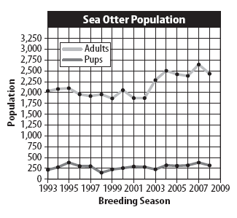
Learn It
Most scientists collect some type of data
when testing a hypothesis. After data are
collected, scientists look for patterns or
trends in the data and draw conclusions.
This process is called interpreting data.
Try It
1. The above graph shows changes in
adult and pup sea otter populations
over many years. Assume that the
number of pups seen during the survey
represents all the pups that were born
and survived in one year—the birthrate.
For example, in the 1997 breeding
season, the birthrate was 300.
2. Make a table showing the population size and the birthrate for the 2001 breeding
season. Repeat for 2002, 2003, and 2004.

40 Populations and Communities
Name Date Class

Skill Practice continued

- In each breeding season, the population increases by the number of pups that were
born and decreases by the number of sea otters that die. Use the following equation to
find the death rate for 2002. Record the death rate on the line below.
Death rate in 2002 = population size in 2001 + birthrate in 2002 − population size in
2002.

Apply It
4. Calculate the death rate in 2004 and compare it to the death rate in 2002.

5. What environmental factors might account for the difference in the death rate between
2002 and 2004?

6. How do you think the population size will change in 2009 and 2010?

7. Key Concept Determine how the birthrate compared to the death rate in 2002
and 2004. Explain how these rates affected the population sizes in 2002 and 2004.

Populations and Communities 41

