Name Date
Weather Forecasts
Directions: Complete this concept map by choosing terms from the word bank and writing them in the correct
spaces.

Doppler | infrared | radar images | satellite images
surface reports | upper-air reports | visible

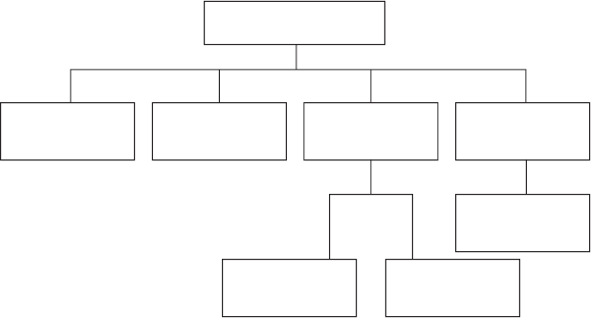
1.
Tools Used to Gather
Weather Information
3. Type

2.
4. Type

5.

6.
7.

Directions: Answer each question on the lines provided.
8. What is a weather forecast?

9. How do weather maps help with weather forecasting?

10. How do computer models help with weather forecasting?

